Looking at the Hardware

Open the System control panel. Click Start -> Control Panel -> System. (Can also right-click on Computer and select Properties)

To do: Specify the following:
The version of Windows 7 on your machine: Windows 7 Enterprise

The type of processor: Intel Core 2 Quad

The speed of the processor: 2.83GHz

The amount of RAM: 8GB

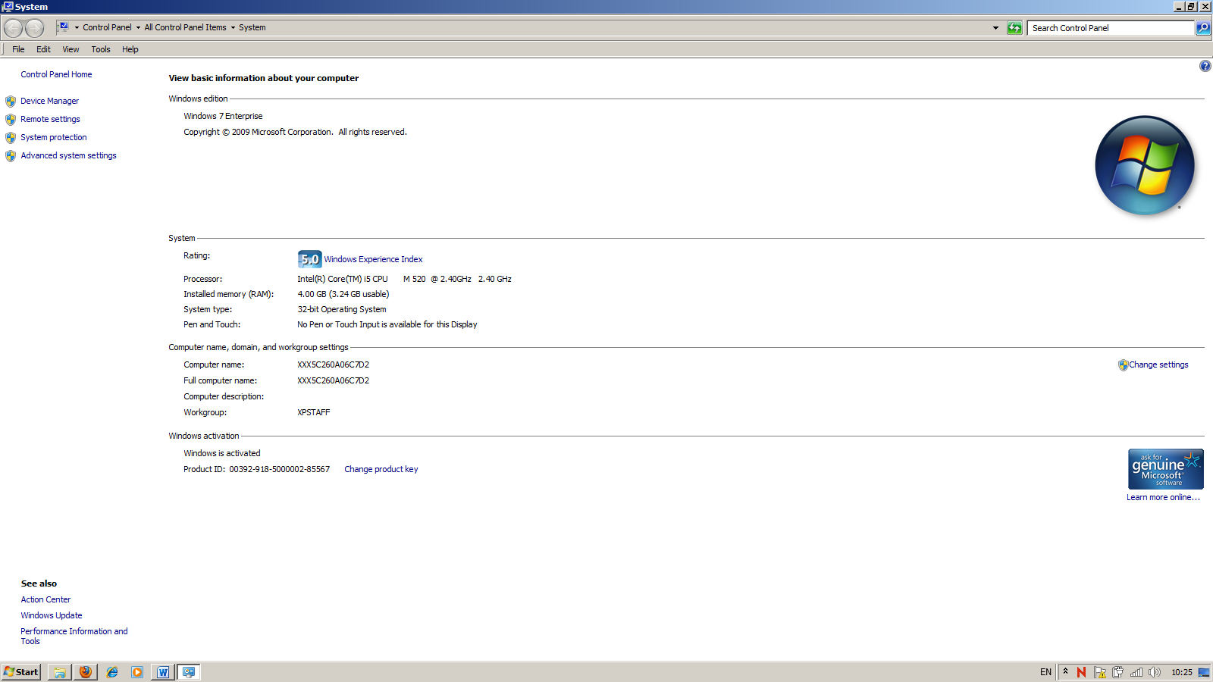

Hard Disks
Two types of disk formats are available in Win 7: NTFS and FAT32. To view information about the file system currently used for a given drive or volume, right click the drive icon in Windows Explorer and choose Properties.

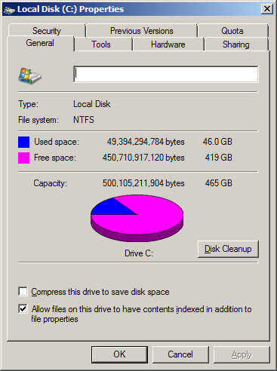
Figure: This dialog box tells you whether the drive is formatted with NTFS or FAT32.

To do: what type of disk format is used on the C drive: NTFS
What is the capacity of the C drive? 296GB

Disk Management
Windows 7 includes a utility called Disk Management that allows you to see the hard drives, partitions etc. You can access in any of the following ways:
- Click on Programs -> Administrative Tools -> Computer Management, and then select Disk Management from the console pane on the left side of the window.
- In Windows Explorer, right click on Computer and select Manage. Then select Disk Management from the console pane on the left side of the window.

As Figure below shows, Disk Management provides a wealth of information about physical disks and the volumes, partitions, and logical drives in place on those disks.

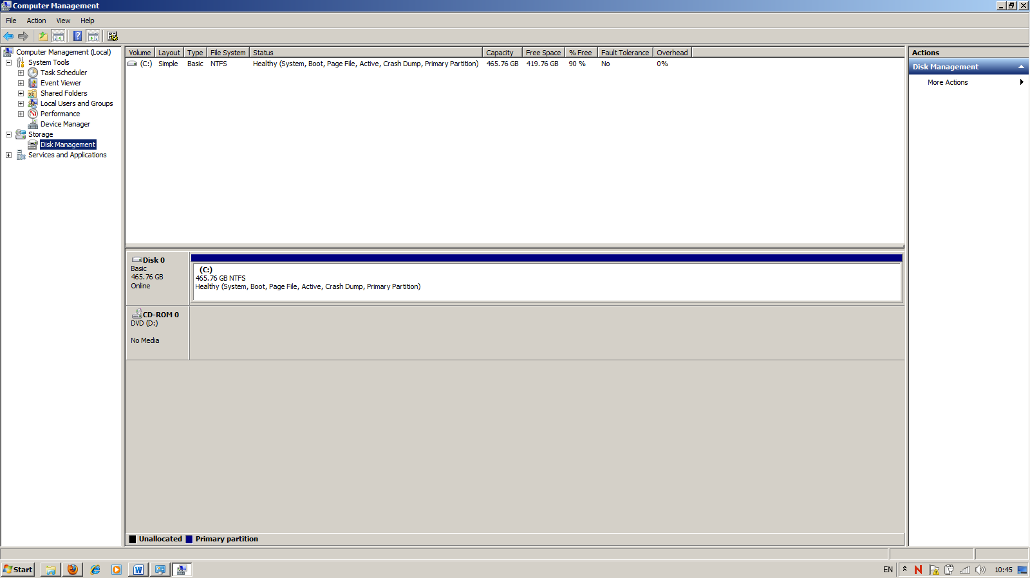
Figure: Use the Disk Management utility to gather information about and manage hard disks and removable disks.

You can use this graphical tool to perform any of the following tasks:
● Check the size, file system, status, and other properties of disks and volumes.
To do: How many partitions are on your machine? 1
For each partition specify the following:
Volume: C
Layout: Simple
Type: Basic
File System: NTFS
Capacity: 297.12GB
Free Space: 116GB
Note: Copy the above for each volume

A Crash Course in Device Drivers
Before Windows can work with any piece of hardware, it requires a compatible, properly configured device driver. Drivers are compact control programs that hook directly into Windows and handle the essential tasks of communicating your instructions to a hardware device and then relaying data back to you. After you set up a hardware device, its driver loads automatically and runs as part of the operating system, without requiring any further intervention on your part.
Windows 7 includes an enormous library of drivers - for printers, keyboards, scanners, mice and related pointing devices, digital cameras, and other devices - in the C:\Windows\System32\drivers folder. All drivers stored here are certified to be fully compatible with Windows 7 and digitally signed by Microsoft. When you install a new Plug and Play compatible device, Windows checks this location first. If it finds a suitable
driver, installation proceeds automatically.
Finding Information About an Installed Driver
Device Manager is a graphical utility that provides detailed information about all installed hardware. To open Device Manager, use any of the following techniques:
- In Windows Explorer, right click on Computer and select Manage. Then select Device Manager from the left pane of the Computer Management console, under System Tools.
- From Control Panel, double-click the System icon and then click on the Device Manager link on the top left hand side of the window.

As Figure below shows, Device Manager is organized as a hierarchical list that inventories every piece of hardware within or connected to your computer. The default view shows devices by type.

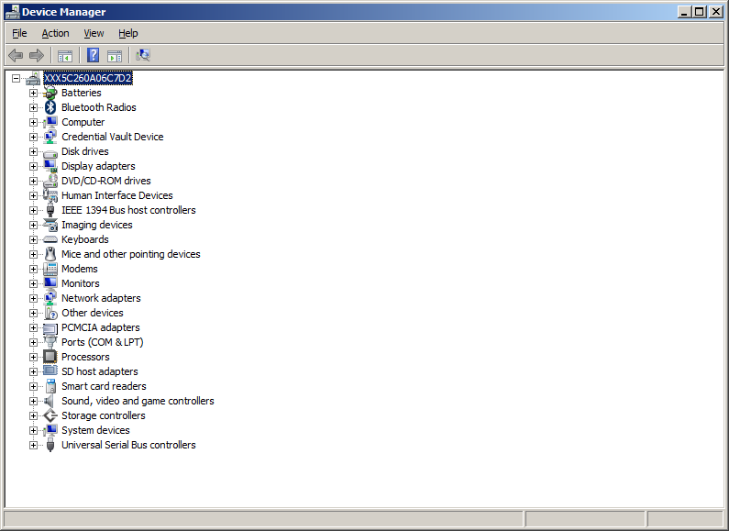

Click the plus sign to the left of each category in Device Manager to see individual devices within that category.
Note: a yellow exclamation point means this device has a configuration problem

Viewing Device and Driver Details
To view information about a specific device, double-click its entry in Device Manager’s list of installed devices. Each device has its own multi-tabbed properties dialog box. At a minimum, each device includes two tabs, General and Driver. The General tab lists basic facts about the device, including the device name, the name of its manufacturer, and its current status. The Driver tab lists version information about the currently installed driver for the selected device. To view additional information about an installed driver, click the Driver Details button. The Driver File Details dialog box provides far more comprehensive information, including the names and locations of all associated files. Selecting any file name from this list displays details for that file in the lower portion of the dialog box.

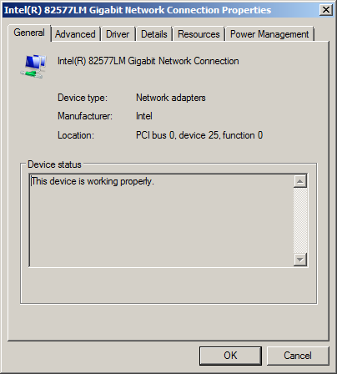

To do:
For the processor and network adapter specify: (PROCESSOR)
the device name Intel® Core™2 Quad CPU
the name of its manufacturer: Intel
its current status This device is working properly
the driver provider: Microsoft
the location and name of the driver file:
C:\\Windows\system32\DRIVERS\intelppm.sys

For the processor and network adapter specify: (Network Adapter)
the device name Intel® 82567LM3- Gigabit Network Connection
the name of its manufacturer: Intel
its current status This device is working properly
the driver provider: Intel
the location and name of the driver file:
C:\\Windows\system32\DRIVERS\e1k62x64.sys

